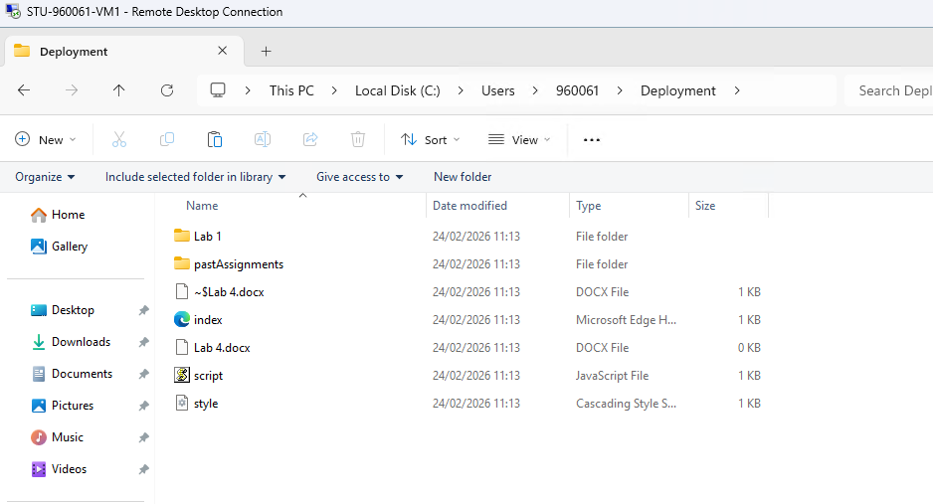
I opened my VM and opened my cloned git repository into the VM
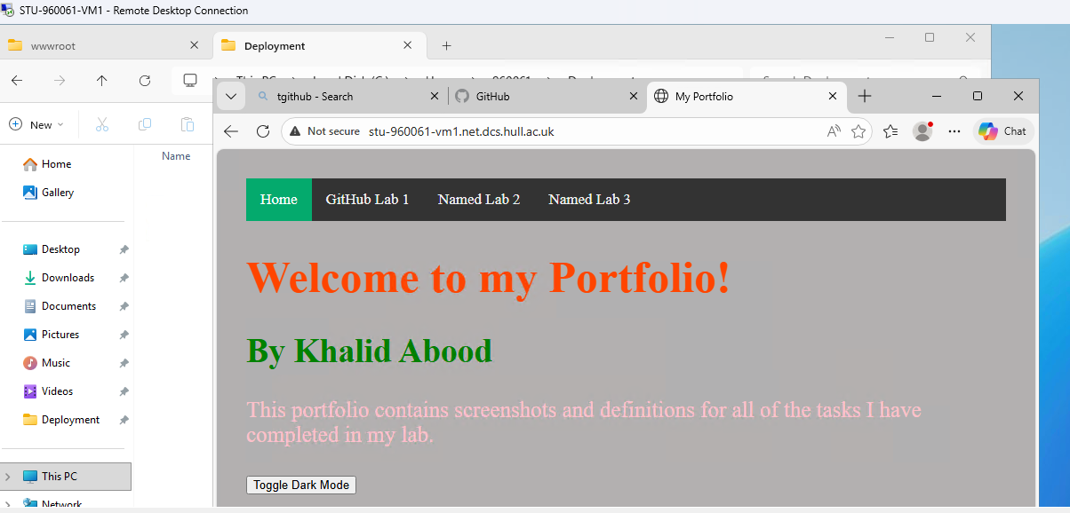
I moved my deployment folder into wwwroot which let me access the page in the browser
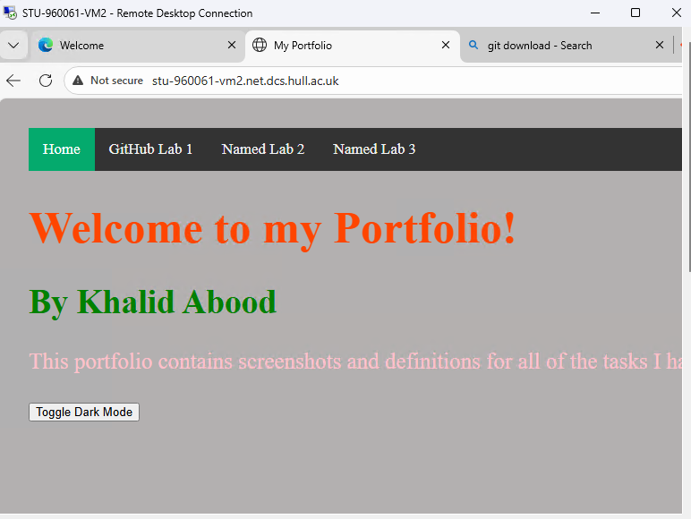
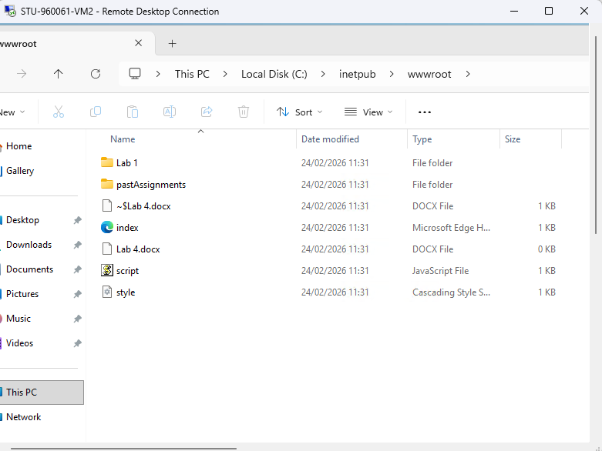
I redid the steps for VM-2 and got my website to work again
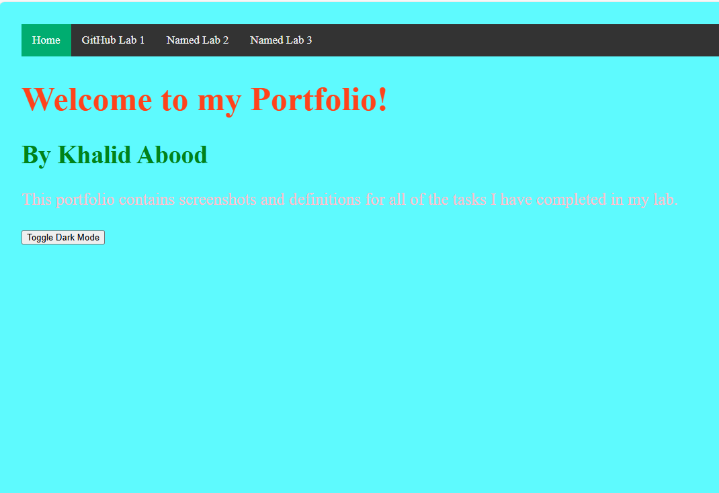
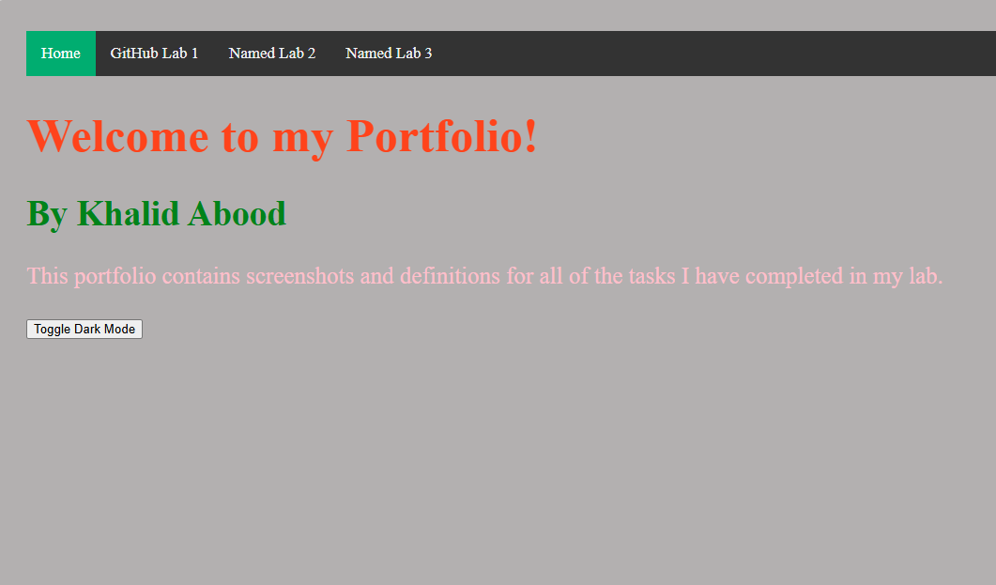
I changed the background colour from grey to cyan. The 1st screenshot is the development VM and the 2nd screenshot is the deployment. This is useful as the first VM can be used to test changes before release onto the real version or the deployment VM.

